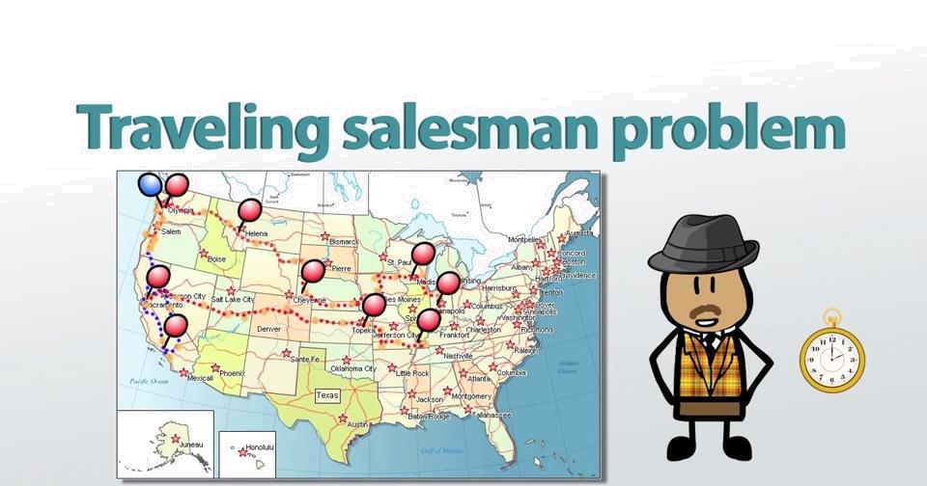
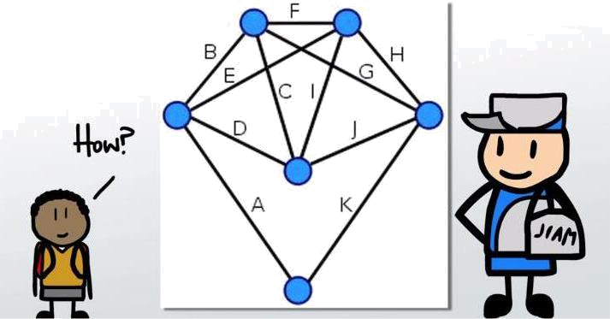
Problem Statement

- Given a list of cities and the distances between each pair of cities, what is the shortest possible route that visits each city exactly once and returns to the origin city?

- In this assignment you will be solving TSP using local search.
First Choice Hill Climbing
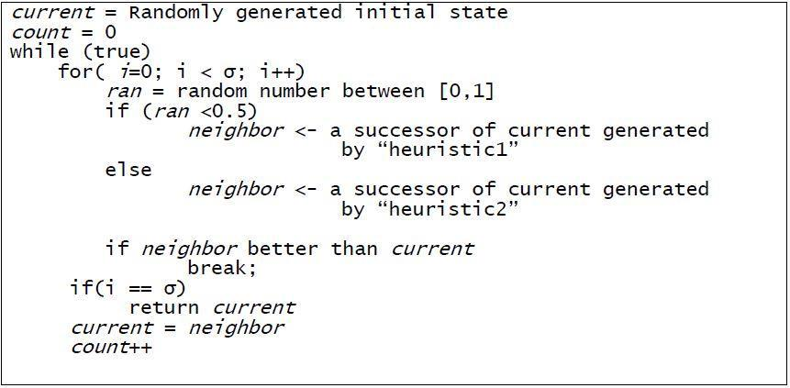
Heuristics for generating neighbors

Randomly pick two cities from the route and exchange them.

Heuristics for Tour improvement

It attempts to improve the current tour by first moving a chain of three consecutive vertices in a different location (and possibly reversing it) to find an improved route. All possible chain is checked. If no improvement can be obtained, the process is then repeated with chains of two consecutive vertices, and then with single vertices.
Heuristics for Tour improvement
